Super Primes
# Source: AI Source: Provided by: [Data Path: Persons Table -> ID Column: 1, Name_En Column: Motasem Essam] -> From: [ChatGPT] on [7/13/2026]
A super prime is a prime number whose position (index) in the ordered sequence of prime numbers is also a prime number.
For example,
$$5$$
is a super prime because it is the 3rd prime number, and
$$3$$
is itself prime.
Super primes are studied in number theory, prime sequences, and computational mathematics.

Definition
# Source: AI Source: Provided by: [Data Path: Persons Table -> ID Column: 1, Name_En Column: Motasem Essam] -> From: [ChatGPT] on [7/13/2026]
A super prime is a prime number $p_{n}$such that its index $n$in the sequence of prime numbers is also a prime number.
If
$$p_{1}=2, p_{2}=3, p_{3}=5, p_{4}=7,…$$
then
$$p_{n}$$
is a super prime whenever
$$n$$
is prime.

Prime Number Sequence
# Source: AI Source: Provided by: [Data Path: Persons Table -> ID Column: 1, Name_En Column: Motasem Essam] -> From: [ChatGPT] on [7/13/2026]
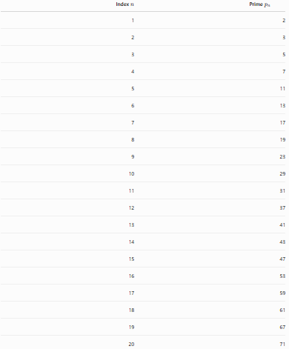
Index $n$ | Prime $p_{n}$
1 | 2
2 | 3
3 | 5
4 | 7
5 | 11
6 | 13
7 | 17
8 | 19
9 | 23
10 | 29
11 | 31
12 | 37
13 | 41
14 | 43
15 | 47
16 | 53
17 | 59
18 | 61
19 | 67
20 | 71
Since the prime indices are
$$2, 3, 5, 7, 11, 13, 17, 19,…$$
the corresponding super primes are
$$3, 5, 11, 17, 31, 41, 59, 67,…$$

Rules for Super Primes

1. The Number Must Be Prime
# Source: AI Source: Provided by: [Data Path: Persons Table -> ID Column: 1, Name_En Column: Motasem Essam] -> From: [ChatGPT] on [7/13/2026]
The number itself must be prime.
Example
$$41$$
is prime.

2. Determine Its Position in the Prime Sequence
# Source: AI Source: Provided by: [Data Path: Persons Table -> ID Column: 1, Name_En Column: Motasem Essam] -> From: [ChatGPT] on [7/13/2026]
Find where the prime appears in the ordered list of primes.
Example
The prime sequence begins
$$2, 3, 5, 7, 11, 13, 17, 19, 23, 29, 31, 37, 41,…$$
Thus,
$$41$$
is the
$${13}^{\text{th}}$$
prime.

3. The Position Must Also Be Prime
# Source: AI Source: Provided by: [Data Path: Persons Table -> ID Column: 1, Name_En Column: Motasem Essam] -> From: [ChatGPT] on [7/13/2026]
Since
$$13$$
is prime,
$$41$$
is a super prime.

4. If the Position Is Composite, the Number Is Not a Super Prime
# Source: AI Source: Provided by: [Data Path: Persons Table -> ID Column: 1, Name_En Column: Motasem Essam] -> From: [ChatGPT] on [7/13/2026]
Example
Consider
$$29.$$
It is the
$${10}^{\text{th}}$$
prime.
Since
$$10$$
is composite,
29 is not a super prime.

5. The Number 2 Is Not a Super Prime
# Source: AI Source: Provided by: [Data Path: Persons Table -> ID Column: 1, Name_En Column: Motasem Essam] -> From: [ChatGPT] on [7/13/2026]
Although
$$2$$
is prime,
it is the
$$1^{\text{st}}$$
prime,
and
$$1$$
is not prime.
Therefore,
2 is not a super prime.

6. There Are Infinitely Many Super Primes
# Source: AI Source: Provided by: [Data Path: Persons Table -> ID Column: 1, Name_En Column: Motasem Essam] -> From: [ChatGPT] on [7/13/2026]
Since there are infinitely many prime numbers and infinitely many prime indices, there are infinitely many super primes.

First Super Primes
# Source: AI Source: Provided by: [Data Path: Persons Table -> ID Column: 1, Name_En Column: Motasem Essam] -> From: [ChatGPT] on [7/13/2026]
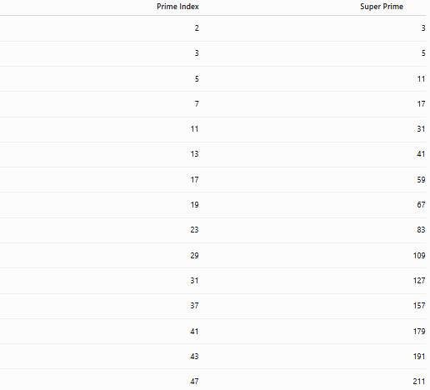
Prime Index | Super Prime
2 | 3
3 | 5
5 | 11
7 | 17
11 | 31
13 | 41
17 | 59
19 | 67
23 | 83
29 | 109
31 | 127
37 | 157
41 | 179
43 | 191
47 | 211

Examples
# Source: AI Source: Provided by: [Data Path: Persons Table -> ID Column: 1, Name_En Column: Motasem Essam] -> From: [ChatGPT] on [7/13/2026]
Example 1
Determine whether
$$5$$
is a super prime.
Prime sequence:
$$2, 3, 5.$$
The number
$$5$$
is the
$$3^{\text{rd}}$$
prime.
Since
$$3$$
is prime,
5 is a super prime.

Example 2
Determine whether
$$17$$
is a super prime.
Prime sequence:
$$2, 3, 5, 7, 11, 13, 17.$$
The index is
$$7.$$
Since
$$7$$
is prime,
17 is a super prime.

Example 3
Determine whether
$$29$$
is a super prime.
The index of
$$29$$
is
$$10.$$
Since
$$10$$
is composite,
29 is not a super prime.

Example 4
Determine whether
$$41$$
is a super prime.
The index is
$$13.$$
Since
$$13$$
is prime,
41 is a super prime.

Example 5
Determine whether
$$59$$
is a super prime.
The index is
$$17.$$
Since
$$17$$
is prime,
59 is a super prime.

Example 6
Determine whether
$$67$$
is a super prime.
The index is
$$19.$$
Since
$$19$$
is prime,
67 is a super prime.

Common Super Primes
# Source: AI Source: Provided by: [Data Path: Persons Table -> ID Column: 1, Name_En Column: Motasem Essam] -> From: [ChatGPT] on [7/13/2026]
Some well-known super primes are
$$3, \\ 5, \\ 11, \\ 17, \\ 31, \\ 41, \\ 59, \\ 67, \\ 83, \\ 109, \\ 127, \\ 157, \\ 179, \\ 191, \\ 211.$$

How to Determine Whether a Number Is a Super Prime
# Source: AI Source: Provided by: [Data Path: Persons Table -> ID Column: 1, Name_En Column: Motasem Essam] -> From: [ChatGPT] on [7/13/2026]
- Verify that the number is prime.
- Find its position in the ordered list of prime numbers.
- Check whether the position is prime.
- If both conditions hold, the number is a super prime.
Example
Check
$$31.$$
Prime sequence:
$$2, 3, 5, 7, 11, 13, 17, 19, 23, 29, 31.$$
The index is
$$11.$$
Since
$$11$$
is prime,
31 is a super prime.

Real-Life Applications
# Source: AI Source: Provided by: [Data Path: Persons Table -> ID Column: 1, Name_En Column: Motasem Essam] -> From: [ChatGPT] on [7/13/2026]
Super primes are primarily used in:
- Number theory research
- Computational mathematics
- Prime sequence analysis
- Algorithm development
- Mathematical software
- Computer science
- Mathematics education
- Recreational mathematics
- Research on prime distributions

Real-Life Examples
# Source: AI Source: Provided by: [Data Path: Persons Table -> ID Column: 1, Name_En Column: Motasem Essam] -> From: [ChatGPT] on [7/13/2026]
1. Number Theory Research
Researchers study super primes to investigate relationships between prime values and their positions.

2. Computational Mathematics
Algorithms generate super primes by indexing prime sequences.

3. Mathematical Software
Computer algebra systems can efficiently compute super primes using prime-generation algorithms.

4. Prime Sequence Analysis
Super primes help analyze patterns within the ordered sequence of prime numbers.

5. Recreational Mathematics
They are a classic example of applying one mathematical property (primality) to another (the index).

6. Mathematics Education
Super primes illustrate the concepts of sequences, indexing, and prime numbers simultaneously.

Common Mistakes
# Source: AI Source: Provided by: [Data Path: Persons Table -> ID Column: 1, Name_En Column: Motasem Essam] -> From: [ChatGPT] on [7/13/2026]
- Confusing the value of the prime with its position.
- Assuming every prime is a super prime.
- Forgetting that 1 is not prime, so 2 is not a super prime.
- Counting the prime sequence incorrectly.
- Confusing super primes with Sophie Germain primes or safe primes.

Key Points
# Source: AI Source: Provided by: [Data Path: Persons Table -> ID Column: 1, Name_En Column: Motasem Essam] -> From: [ChatGPT] on [7/13/2026]
- A super prime is a prime whose index in the prime sequence is also prime.
- The number and its position must both be prime.
- The smallest super prime is 3.
- The prime 2 is not a super prime because its index is 1.
- There are infinitely many super primes.
- Super primes are studied in number theory and prime sequence analysis.

Super Primes vs. Prime Numbers
# Source: AI Source: Provided by: [Data Path: Persons Table -> ID Column: 1, Name_En Column: Motasem Essam] -> From: [ChatGPT] on [7/13/2026]
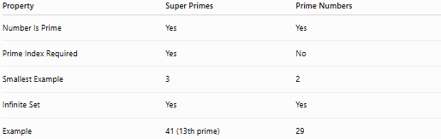
Property | Super Primes | Prime Numbers
Number Is Prime | Yes | Yes
Prime Index Required | Yes | No
Smallest Example | 3 | 2
Infinite Set | Yes | Yes
Example | 41 (13th prime) | 29

Super Primes vs. Twin Primes
# Source: AI Source: Provided by: [Data Path: Persons Table -> ID Column: 1, Name_En Column: Motasem Essam] -> From: [ChatGPT] on [7/13/2026]
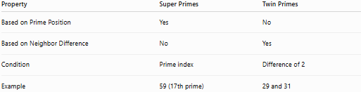
Property | Super Primes | Twin Primes
Based on Prime Position | Yes | No
Based on Neighbor Difference | No | Yes
Condition | Prime index | Difference of 2
Example | 59 (17th prime) | 29 and 31

Conclusion
# Source: AI Source: Provided by: [Data Path: Persons Table -> ID Column: 1, Name_En Column: Motasem Essam] -> From: [ChatGPT] on [7/13/2026]
A super prime is a prime number whose position in the ordered sequence of prime numbers is itself prime. For example, 41 is a super prime because it is the 13th prime, and 13 is also prime. Super primes combine the concepts of prime numbers and prime indexing, making them an interesting topic in number theory, prime sequence analysis, and computational mathematics. Since there are infinitely many prime indices, there are also infinitely many super primes.

